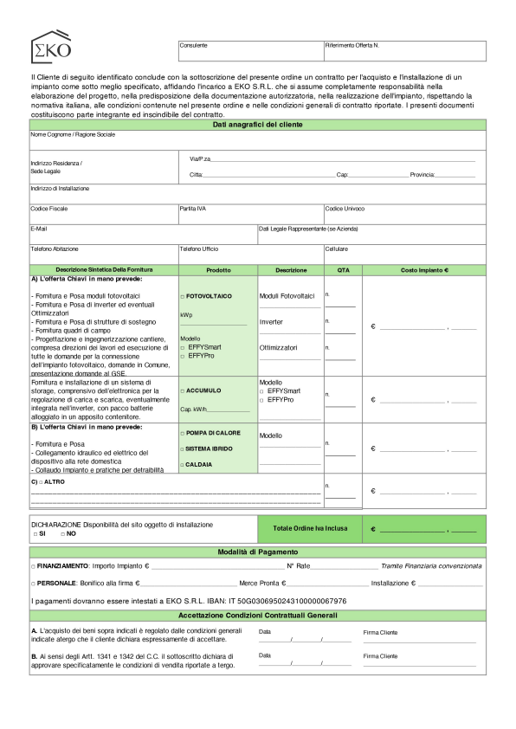




Modulo
Ordine
EKOS.R.L.
Email:info@ekosrl.net
C.F./P.IVA:03879090128
V.lePapaGiovanniXXIII,103-21015LonatePozzoloVA
N.Verde:800268022|WPBusiness:3338058838
VersioneDocumento:v9.25
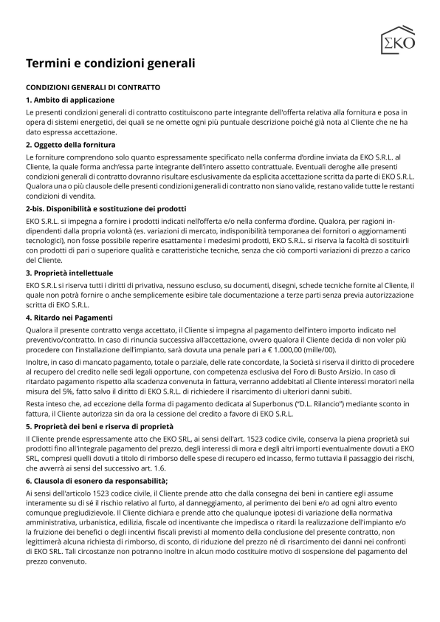



EKOS.R.L.
V.lePapaGiovanniXXIII,103-21015LonatePozzoloVA
Email:info@ekosrl.net
N.Verde:800268022|WPBusiness:3338058838
C.F./P.IVA:03879090128 VersioneDocumento:v9.25



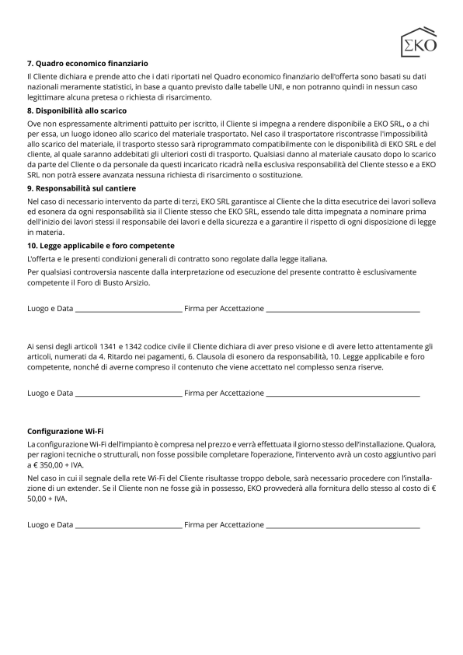
EKOS.R.L.
V.lePapaGiovanniXXIII,103-21015LonatePozzoloVA
Email:info@ekosrl.net
N.Verde:800268022|WPBusiness:3338058838
C.F./P.IVA:03879090128 VersioneDocumento:v9.25

